UNITED STATES PROBATION AND PRETRIAL SERVICES
DISTRICT OF SOUTH CAROLINA
EMPLOYMENT DISPUTE RESOLUTION PLAN
Based on the Model EDR Plan, Guide to Judiciary Policy, Vol. 12, Appx. 2A
- INTRODUCTION

The Federal Judiciary is committed to a workplace of respect, civility, fairness, tolerance, and dignity, free of discrimination and harassment. These values are essential to the Judiciary, which holds its Judges and Employees to the highest standards. All Judges and Employees are expected to treat each other accordingly.

This Plan provides options for the reporting and resolution of allegations of wrongful conduct (discrimination, sexual, racial, or other discriminatory harassment, abusive conduct, and retaliation) in the workplace. Early action is the best way to maintain a safe work environment. All Judges, Employing Offices, and Employees have a responsibility to promote workplace civility, prevent harassment or abusive conduct, and to take appropriate action upon receipt of reliable information indicating a likelihood of wrongful conduct under this Plan. See Code of Conduct for Judicial Employees, Canon 3(C).

This Plan applies to all Judges, current and former Employees (including all law clerks; chambers employees; paid and unpaid interns, externs, and other volunteers; federal public defender employees; and probation and pretrial services employees), and applicants for employment who have been interviewed. The following persons cannot seek relief under this Plan: Judges, applicants for judicial appointment, Criminal Justice Act panel attorneys and applicants, investigators and service providers, community defender employees, volunteer mediators, and any other non-Employees not specified above. See Appendix 1 for full definitions of Judges and Employees.
- WRONGFUL CONDUCT
- This Plan prohibits wrongful conduct that occurs during the period of employment or the interview process (for an applicant). Wrongful conduct includes:
  - discrimination;
  - sexual, racial, and other discriminatory harassment;
  - abusive conduct; and
  - retaliation (including retaliation as described in the Whistleblower Protection Provision in Guide to Judiciary Policy, Vol. 12, § 220.10.20(c)).
Wrongful conduct can be verbal, non-verbal, physical, or non-physical. Wrongful conduct also includes conduct that would violate the following employment laws and policy, as applied to the Judiciary by Judicial Conference policy:

  - Title VII, Civil Rights Act of 1964;
  - Age Discrimination in Employment Act of 1967;
  - Americans with Disabilities Act of 1990 and the Rehabilitation Act of 1973;
  - Family and Medical Leave Act of 1993;
  - Uniformed Services Employment and Reemployment Rights Act of 1994;
  - Whistleblower Protection Provision (Guide, Vol. 12, § 220.10.20(c));
  - Worker Adjustment and Retraining Notification Act;
  - Occupational Safety and Health Act; and
  - The Employee Polygraph Protection Act of 1988.

See Guide, Vol. 12, Ch. 2.
- Discrimination is an adverse employment action that materially affects the terms, conditions, or privileges of employment (such as hiring, firing, failing to promote, or a significant change in benefits) based on the following Protected Categories: race, color, sex, gender, gender identity, pregnancy, sexual orientation, religion, national origin, age (40 years and over),1 or disability.
- Discriminatory harassment occurs when a workplace is permeated with discriminatory intimidation, ridicule, and insult that is sufficiently severe or pervasive to alter the conditions of the employment and create an abusive working environment. Discriminatory harassment includes sexual harassment.
Examples of conduct that may give rise to discriminatory harassment: racial slurs; derogatory comments about a person’s ethnicity, culture, or foreign accent; or jokes about a person’s age, disability, or sexual orientation.
Examples of conduct that may give rise to sexual harassment: suggestive or obscene notes, emails, text messages, or other types of communications; sexually degrading comments; display of sexually suggestive objects or images; unwelcome or inappropriate touching or physical contact; unwelcome sexual advances or propositions; inappropriate remarks of a sexual nature or about physical appearance; or employment action affected by submission to, or rejection of, sexual advances.
- Abusive Conduct is a pattern of demonstrably egregious and hostile conduct not based on a Protected Category that unreasonably interferes with an Employee’s work and creates an abusive working environment. Abusive conduct is threatening, oppressive, or intimidating.
Abusive conduct does not include communications and actions reasonably related to performance management, including but not limited to: instruction, corrective

1 The age discrimination provision does not apply to hiring, retirement, or separation of probation and pretrial services officers under 5 U.S.C. chapters 83 and 84.

criticism, and evaluation; performance improvement plans; duty assignments and changes to duty assignments; office organization; progressive discipline; and adverse action.
- Retaliation is a materially adverse action taken against an Employee for reporting wrongful conduct; for assisting in the defense of rights protected by this Plan; or for opposing wrongful conduct. Retaliation against a person who reveals or reports wrongful conduct is itself wrongful conduct.
- REPORTING WRONGFUL CONDUCT
The Judiciary encourages early reporting and action on wrongful conduct. Employees who experience, observe, or learn of reliable evidence of sexual, racial, or other discriminatory harassment or abusive conduct are strongly encouraged to take appropriate action, including reporting it to a supervisor, human resources professional, Unit Executive, Employment Dispute Resolution (“EDR”) Coordinator, Chief Judge, Chief Circuit Judge, Circuit Director of Workplace Relations, or to the national Office of Judicial Integrity. See Code of Conduct for Judicial Employees, Canon 3(C). Employees are also encouraged to report wrongful conduct in the workplace by non-Employees. Court and chambers’ confidentiality requirements do not prevent any Employee—including law clerks—from revealing or reporting wrongful conduct by any person.

- OPTIONS FOR RESOLUTION

The Judiciary’s goal is to address wrongful conduct as soon as possible and to provide multiple, flexible options for doing so. An Employee is always free to address a conduct issue directly with the person who allegedly committed wrongful conduct or to contact a colleague, supervisor, Unit Executive, Judge, Chief Judge, or other individual to discuss or address the situation. This Plan provides the following additional options, and Employees may choose the option(s) that best fit their needs and comfort level.

- Plan Options. This Plan provides three options to address wrongful conduct, as explained in detail below:

Informal Advice
  - Assisted Resolution
  - Formal Complaint

- General Rights. All options for resolution are intended to respect the privacy of all involved to the greatest extent possible, and to protect the fairness and thoroughness of the process by which allegations of wrongful conduct are initiated, investigated, and ultimately resolved.

  - Confidentiality. All individuals involved in the processes under this Plan must protect the confidentiality of the allegations of wrongful conduct. Information will be shared only to the extent necessary and only with those whose involvement is necessary to address the situation. An assurance of confidentiality must yield when there is reliable information of wrongful conduct that threatens the safety or security of any person or that is serious or egregious such that it threatens the integrity of the Judiciary.

Confidentiality obligations in the Code of Conduct for Judicial Employees concerning use or disclosure of confidential information received in the course of official duties do not prevent nor should they discourage Employees from reporting or disclosing wrongful conduct, including sexual, racial, or other forms of discriminatory harassment by a Judge, supervisor, or other person.

Supervisors, Unit Executives, and Judges must take appropriate action when they learn of reliable information of wrongful conduct, such as sexual, racial, or other discriminatory harassment, which may include informing the appropriate Chief Judge.

  - Impartiality. All investigations, hearings, and other processes under this Plan must be conducted in a thorough, fair, and impartial manner. The EDR Coordinator, the Circuit Director of Workplace Relations, and the Presiding Judicial Officer must be impartial and may not act as an advocate for either Party. The EDR Coordinator, Circuit Director of Workplace Relations, or Presiding Judicial Officer must recuse if he or she participated in, witnessed, or was otherwise involved with the conduct or employment action giving rise to the claim. Recusal of these individuals is also required if the matter creates an actual conflict or the appearance of a conflict.

  - Right to representation. Both the Employee and the Employing Office responsible for providing any remedy have the right to be represented by an attorney or other person of their choice at their own expense. Another Employee may assist the Employee or Employing Office if doing so will not constitute a conflict of interest or unduly interfere with his or her duties, as determined by the assisting Employee’s appointing officer.

  - Interim Relief. An Employee, including a law clerk or other chambers employee, who pursues any of the options under this Plan may request transfer, an alternative work arrangement, or administrative leave if the Employee alleges egregious conduct by a supervisor, Unit Executive, or Judge that makes it untenable to continue working for that person. Any such

request must be made to the Unit Executive or Chief Judge, as appropriate, to determine appropriate interim relief, if any, taking into consideration the impact on any Employing Office.

  - Allegations Regarding a Judge. An Employee alleging that a Judge has engaged in wrongful conduct may use any of the options for resolution as set forth in Section C. An Employee may also file a complaint under the Judicial Conduct and Disability Act, 28 U.S.C. §§ 351-364.

Specific Options

  - Informal Advice. An Employee may contact an EDR Coordinator, Circuit Director of Workplace Relations, or the national Office of Judicial Integrity for confidential advice and guidance (see § IV.B.1) about a range of topics including:

    - the rights and protections afforded under this Plan, the Judicial Conduct and Disability Act, and any other processes;
    - ways to respond to wrongful conduct as it is happening; and/or
    - options for addressing the conduct, such as informal resolution, participating in Assisted Resolution, or pursuing a Formal Complaint under this Plan, the Judicial Conduct and Disability Act, or any other processes.

  - Assisted Resolution. Assisted Resolution is an interactive, flexible process that may include:

    - discussing the matter with the person whose behavior is of concern;
    - conducting a preliminary investigation, including interviewing persons alleged to have violated rights under this Plan and witnesses to the conduct;
    - engaging in voluntary mediation between the persons involved; and/or
    - resolving the matter by agreement.

- To pursue this option, an Employee must contact an EDR Coordinator or Circuit Director of Workplace Relations and complete a “Request for Assisted Resolution” (Appendix 2). An Employee asserting any claim of abusive conduct must first use Assisted Resolution before filing a Formal Complaint. Filing a Request for Assisted Resolution does not toll (extend) the time for filing a Formal Complaint under § IV.C.3 unless one of the Parties requests, and the Chief Judge or Presiding Judicial Officer grants, an extension of time for good cause, as permitted in
§ IV.C.3.a.

- If the allegations concern the conduct of a Judge, the Chief Judge of the appropriate district or circuit Court must be notified and will be responsible for coordinating any Assisted Resolution and/or taking any other action required or appropriate under the circumstances. See, e.g., Rules for Judicial-Conduct and Judicial-Disability Proceedings.

- If the allegations concern the conduct of an Employee, the EDR Coordinator or Circuit Director of Workplace Relations will coordinate Assisted Resolution and must notify the appropriate Unit Executive(s). The Unit Executive is responsible for assessing the allegation(s) and taking appropriate steps to resolve the matter. If the allegations concern the conduct of a Unit Executive, the EDR Coordinator must notify the Chief Judge, who is responsible for assessing the allegation(s) and addressing the matter as appropriate.

- The Unit Executive or Chief Judge responsible for assessing the allegations, as indicated in (b) and (c) above, may deny the Request for Assisted Resolution at any time if he or she concludes it is frivolous; it does not allege violations of the rights or protections in this Plan; the alleged conduct arises out of the same facts and circumstances, and was resolved by, a previous EDR Complaint or other claim process or procedure; or on other appropriate grounds.

- If Assisted Resolution is successful in resolving the matter, the Parties will so acknowledge in writing.
- The Parties by mutual assent, or the EDR Coordinator or Circuit Director of Workplace Relations in his or her discretion, will determine when to conclude the Assisted Resolution process. If Assisted Resolution is not successful in resolving the matter, the EDR Coordinator or Circuit Director of Workplace Relations will advise the Employee of his or her rights to file a Formal Complaint and/or pursue action under the Judicial Conduct and Disability Act, if applicable, or any other processes.
  - Filing a Formal Complaint. An Employee may file a Formal Complaint (“Complaint”) with any of the Court’s EDR Coordinators to address a claim of wrongful conduct.

- To file a Complaint, an Employee must submit a “Formal Complaint” (Appendix 3) to any of the Court’s EDR Coordinators within 180 days of the alleged wrongful conduct or within 180 days of the time the Employee becomes aware or reasonably should have become aware of such wrongful conduct. Use of the Informal Advice or Assisted Resolution options does not toll (extend) this 180-day

deadline unless the Chief Judge of the Court or the Presiding Judicial Officer grants an extension of time for good cause.

- An Employee asserting any claim of abusive conduct must first use Assisted Resolution before filing a Formal Complaint.

- The Employee filing the Complaint is called the Complainant. The Party responding to the Complaint is the Employing Office that is responsible for providing any appropriate remedy and is called the Respondent. The Complaint is not filed against any specific individual(s) but against the Employing Office.

- Complaint Regarding a Judge. An Employee alleging that a Judge has engaged in wrongful conduct may file a Complaint under this Plan. The EDR Coordinator must immediately provide a copy of the Complaint to the Chief Circuit Judge (or the next most-senior active Circuit Judge, if the allegation is against the Chief Circuit Judge), who will oversee the EDR Complaint process. If a District, Magistrate, or Bankruptcy Judge is the subject of the Complaint, the EDR Coordinator must also provide a copy of the Complaint to the Chief District Judge (unless the Chief District Judge is the subject of the Complaint, in which case the Complaint will be given only to the Chief Circuit Judge).

If a Judge becomes the subject of both a Complaint under this Plan and a complaint under the Judicial Conduct and Disability Act, the Chief Circuit Judge will determine the appropriate procedure for addressing both, which may include holding the EDR claim in abeyance and determining how best to find any common issues of fact, subject to all requirements of the Judicial Conduct and Disability Act, the Rules for Judicial-Conduct and Judicial-Disability Proceedings, and, as practicable, this EDR Plan. Regardless of whether there is a formal complaint under the Judicial Conduct and Disability Act, the Chief Circuit Judge should consider the need for any necessary or appropriate interim relief.

Formal Complaint Procedures and Procedural Rights

  - Appointment of Presiding Judicial Officer. Upon receipt of a Complaint, the EDR Coordinator will immediately send a copy of the Complaint to the Chief Judge of the Court, who will appoint a Presiding Judicial Officer. The Presiding Judicial Officer will be a Judge in the Court or, when appropriate, a Judge from another Court (with the consent of the respective Chief Judge of that Court).

  - Presiding Judicial Officer. The Presiding Judicial Officer oversees the Complaint proceeding. The Presiding Judicial Officer will

provide a copy of the Complaint to the head of the Employing Office against which the Complaint has been filed (Respondent), except when the Presiding Judicial Officer determines for good cause that the circumstances dictate otherwise. The Presiding Judicial Officer must provide the individual alleged to have violated rights under this Plan notice that a Complaint has been filed and the nature and substance of the Complaint allegations.

The Presiding Judicial Officer will provide for appropriate investigation and discovery, allow for settlement discussions, determine any written submissions to be provided by the Parties, determine if a hearing is needed, determine the time, date, and place of the hearing, issue a written decision, and, if warranted, order remedies.

  - Disqualification and Replacement. Either Party may seek disqualification of the EDR Coordinator or the Presiding Judicial Officer by written request to the Chief Judge, explaining why the individual should be disqualified.

If the Presiding Judicial Officer is disqualified, the Chief Judge will designate another Judge to serve as Presiding Judicial Officer. If the EDR Coordinator is disqualified, the Chief Judge will appoint one of the alternate EDR Coordinators or, if available, an EDR Coordinator from another Court (with the consent of the respective Chief Judge of that Court).

  - Response. The Respondent may file a Response to the Complaint with the EDR Coordinator within 30 days of receiving the Complaint. The EDR Coordinator must immediately send the Response to the Presiding Judicial Officer and to the Complainant.

  - Investigation and Discovery. The Presiding Judicial Officer will ensure that the allegations are thoroughly, impartially, and fairly investigated, and may use outside trained investigators if warranted. The investigation may include interviews with persons alleged to have violated rights under this Plan and witnesses, review of relevant records, and collecting documents or other records. The Presiding Judicial Officer will provide for such discovery to the Complainant and Respondent as is necessary and appropriate. The Presiding Judicial Officer will also determine what evidence and written arguments, if any, are necessary for a fair and complete assessment of the allegations and response.

  - Case preparation. The Complainant may use official time to prepare his or her case, so long as it does not unduly interfere with the performance of duties.

  - Extensions of time. Any request for an extension of time must be in writing. The Presiding Judicial Officer may extend any of the deadlines set forth in this EDR Plan for good cause, except for the deadline to issue a written decision, which may only be extended by the Chief Judge.

  - Established Precedent. In reaching a decision, the Presiding Judicial Officer should be guided by judicial and administrative decisions under relevant rules and statutes, as appropriate. The Federal Rules of Evidence and any federal procedural rules do not apply.
  - Notice of Written Decision. The EDR Coordinator or Presiding Judicial Officer will immediately send a copy of the written decision to the Parties, the Chief Judge of the Court, and to any individual alleged to have violated rights protected by this Plan. The EDR Coordinator will inform the Parties of appeal rights, procedures, and deadlines.
- Resolution of Complaint Without a Hearing. After notifying the Parties and giving them an opportunity to respond, the Presiding Judicial Officer may resolve the matter without a hearing.

  - The Presiding Judicial Officer may dismiss a Complaint and issue a written decision at any time in the proceedings on the grounds that: it is untimely filed, is frivolous, fails to state a claim, or does not allege violations of the rights or protections in this Plan; the alleged conduct arises out of the same facts and circumstances, and was resolved by, a previous EDR Complaint or other claim process or procedure; or on other appropriate grounds.

  - After completion of investigation and discovery, the Presiding Judicial Officer may, on his or her own initiative or at the request of either Party, issue a written decision if the Presiding Judicial Officer determines that no relevant facts are in dispute and that one of the Parties is entitled to a favorable decision on the undisputed facts.

  - The Parties may enter into an agreed written settlement if approved in writing by the Presiding Judicial Officer and the Chief Judge.

- Resolution of Complaint With a Hearing. If the Complaint is not resolved in its entirety by dismissal, Assisted Resolution, decision without a

hearing, or settlement, the Presiding Judicial Officer will order a hearing on the merits of the Complaint.

  - Hearing. The hearing will be held no later than 60 days after the filing of the Complaint unless the Presiding Judicial Officer extends the deadline for good cause. The Presiding Judicial Officer will determine the place and manner of the hearing.
  - Notice. The Presiding Judicial Officer must provide reasonable notice of the hearing date, time, and place to the Complainant, the Respondent, and any individual(s) alleged to have violated the Complainant’s rights.
  - Right to Present Evidence. The Complainant and Respondent have the right to present witnesses and documentary evidence and to examine adverse witnesses.
  - Record of Proceedings. A verbatim record of the hearing must be made and will be the official record of the proceeding. This may be a digital recording or a transcript.
  - Written Decision. The Presiding Judicial Officer will make findings of fact and conclusions of law and issue a written decision no later than 60 days after the conclusion of the hearing, unless an extension for good cause is granted by the Chief Judge.

- Remedies. When the Presiding Judicial Officer finds that the Complainant has established by a preponderance of the evidence (more likely than not) that a substantive right protected by this Plan has been violated, the Presiding Judicial Officer may direct the Employing Office to provide remedies for the Complainant. The remedies are limited to providing relief to the Complainant, should be tailored as closely as possible to the specific violation(s) found, and take into consideration the impact on any Employing Office. The Chief Judge and Employing Office (Respondent) must take appropriate action to carry out the remedies ordered in the written decision, subject to any applicable policies or procedures.

  - Allowable Remedies may include:
    - placement of the Complainant in a position previously denied;
    - placement of the Complainant in a comparable alternative position;
    - reinstatement to a position from which the Complainant was previously removed;
    - prospective promotion of the Complainant;

    - priority consideration of the Complainant for a future promotion or position;
    - back pay and associated benefits, when the statutory criteria of the Back Pay Act are satisfied2;
    - records modification and/or expungement;
    - granting of family and medical leave;
    - any reasonable accommodation(s); and
    - any other appropriate remedy to address the wrongful conduct.3

  - Unavailable Remedies. Other than under the Back Pay Act, monetary damages are not available. The Presiding Judicial Officer may award attorney’s fees only if the statutory requirements under the Back Pay Act are satisfied.

- Review of Decision (Appeal). The Complainant and/or the Respondent may appeal the decision to the judicial council of the circuit by submitting in writing a Request for Review of Decision setting forth the grounds for appeal within 30 days of the date of the decision under procedures established by that judicial council (Appendix 4). The EDR Coordinator will inform the Parties of the procedures for seeking review. The decision will be reviewed based on the record created by the Presiding Judicial Officer and will be affirmed if supported by substantial evidence and the proper application of legal principles.

2 Back Pay Act. Remedies under the Back Pay Act, including attorney’s fees, may be ordered only when the statutory criteria of the Back Pay Act are satisfied, which include: (1) a finding of an unjustified or unwarranted personnel action; (2) by an appropriate authority; (3) which resulted in the withdrawal or reduction of all or part of the Employee’s pay, allowances, or differentials. An order of back pay is subject to review and approval by the Director of the Administrative Office of the United States Courts. See 5 U.S.C. § 5596(b)(1) and Guide, Vol. 12, § 690.
3 The issue in an EDR Complaint is whether the Employing Office is responsible for the alleged conduct; it is not an action against any individual. The Presiding Judicial Officer lacks authority to impose disciplinary or similar action against an individual. When there has been a finding of wrongful conduct in an EDR proceeding, an appointing official, or official with delegated authority, should separately assess whether further action, in accordance with any applicable policies and procedures, is necessary to correct and prevent wrongful conduct and promote appropriate workplace behavior, such as:

- requiring counseling or training;
- ordering no contact with the Complainant;
- reassigning or transferring an Employee;
- reprimanding the Employee who engaged in wrongful conduct;
- issuing a suspension, probation, or demotion of the Employee who engaged in wrongful conduct; and/or
- terminating employment for the Employee who engaged in wrongful conduct.

- COURT AND EMPLOYING OFFICE OBLIGATIONS

To ensure that Employees are aware of the options provided by this Plan, and that the Plan is effectively implemented, Courts and Employing Offices must adhere to the following:

- Adopt and Implement EDR Plan. All Courts must adopt and implement an EDR Plan based on this Model EDR Plan. Courts may join with others to adopt consolidated EDR Plans. Any modification of this Model EDR Plan (1) may expand, but should not diminish or curtail, any of the rights or remedies afforded Employees under this Model EDR Plan, and (2) must be approved by the judicial council of its circuit. A copy of each EDR Plan and any subsequent modifications must be filed with the Administrative Office.

- Records. At the conclusion of informal or formal proceedings under this Plan, all papers, files, and reports will be filed with the EDR Coordinator. No papers, files, or reports relating to an EDR matter will be filed in any Employee’s personnel folder, except as necessary to implement an official personnel action.

Final decisions under this Plan will be made available to the public, appropriately redacted, in accordance with procedures established by the judicial council of the circuit.

- EDR Coordinators. The Chief Judge will designate both a primary EDR Coordinator and at least one alternate EDR Coordinator for the Court. A Court may use an EDR Coordinator from another Court, or may use the Circuit Director of Workplace Relations as an alternate EDR Coordinator, if necessary, with the approval of the appropriate Chief Judge. An Employee may choose the EDR Coordinator with whom he or she wishes to seek Informal Advice, request Assisted Resolution, or file a Complaint under this EDR Plan.
An EDR Coordinator must be an Employee who is not a Unit Executive. A Judge may not be an EDR Coordinator. All EDR Coordinators must be trained and certified as set forth in the EDR Interpretive Guide and Handbook.
- Advising Employees of their Rights. Courts and Employing Offices must:
  - prominently post on their internal and external main homepages a direct link, labeled “Your Employee Rights and How to Report Wrongful Conduct,” to:
    - the entire EDR Plan with all Appendices and relevant contact information;

    - the Judicial Conduct and Disability Act, the Rules for Judicial-Conduct and Judicial-Disability Proceedings, and the Judicial Conduct and Disability Complaint form; and
    - contact information for all of the Court’s EDR Coordinators, Circuit Director of Workplace Relations, and the national Office of Judicial Integrity.

  - prominently display in the workplace:
    - the posters set forth in Appendix 5; and
    - an Anti-Discrimination and Harassment Notice that: (a) states that discrimination or harassment based on race, color, sex, gender, gender identity, pregnancy, sexual orientation, religion, national origin, age (40 years and over), or disability is prohibited; (b) explains that Employees can report, resolve, and seek remedies for discrimination, harassment, or other wrongful conduct under the EDR Plan by contacting any of the Court’s EDR Coordinators and/or the Circuit Director of Workplace Relations, and/or the national Office of Judicial Integrity; (c) identifies the names and contact information of all Court EDR Coordinators, the Circuit Director of Workplace Relations, and the national Office of Judicial Integrity; and
(d) states where the EDR Plan can be located on the Court’s website.

  - ensure that each new Employee receive an electronic or paper copy of the EDR Plan and acknowledge in writing that he or she has read the Plan; and

  - conduct training annually for all Judges and Employees, including chambers staff, to ensure that they are aware of the rights and obligations under the EDR Plan and the options available for reporting wrongful conduct and seeking relief.

- Reporting. Courts and Employing Offices will provide annually, to the Administrative Office of the United States Courts, data on: (1) the number and types of alleged violations for which Assisted Resolution was requested, and for each matter, whether it was resolved or was also the subject of a Complaint under this Plan or other complaint; (2) the number and type of alleged violations for which Complaints under this Plan were filed; (3) the resolution of each Complaint under this Plan (dismissed or settled prior to a decision, or decided with or without a hearing); and (4) the rights under this Plan that were found by decision to have been violated. Courts and Employing Offices should also provide any information that may be helpful in identifying the conditions that may have enabled wrongful conduct or prevented its discovery, and what precautionary or curative steps should be undertaken to prevent its recurrence.

- Appendices Attached:

  - Definitions
  - Request for Assisted Resolution
  - Formal Complaint Form
  - Request for Review of Decision Procedures and Sample Form (each Court to attach its circuit’s Request for Review Procedures)
  - Posters

This Plan supersedes all prior Model Equal Employment Opportunity and Employment Dispute Resolution Plans.

Effective date: September 17, 2021

DEFINITIONS APPENDIX 1

Circuit Director of Workplace Relations: A circuit Employee who coordinates workplace conduct issues and the implementation of all Court EDR Plans within the circuit. The scope of duties may vary by circuit, but generally, a Circuit Director of Workplace Relations may: provide Informal Advice and Assisted Resolution under any EDR Plan within the circuit; assist in training the EDR Coordinators within the circuit; provide or arrange for training throughout the circuit on workplace conduct, discrimination, and sexual harassment; and collect and analyze statistical data and other information relevant to workplace conduct matters.
Court: The Court (Courts of Appeals, District Courts, Bankruptcy Courts, Court of Federal Claims and Court of International Trade, or of any Court created by an Act of Congress in a territory that is invested with any jurisdiction of a District Court of the United States) in which the Employing Office that would be responsible for ordering redress, correction, or abatement of a violation of rights under this EDR Plan is located. In the case of disputes involving employees of the federal public defender, “Court” refers to the appropriate Court of Appeals. In the case of disputes involving probation and pretrial services, “Court” refers to the appropriate District Court.
EDR Coordinator: A Court Employee, other than a Judge or Unit Executive, designated by the Chief Judge to coordinate all of the Options for Resolution provided for in this Plan. The EDR Coordinator provides confidential advice and guidance (see § IV.B.1.) if an Employee seeks Informal Advice; coordinates the Assisted Resolution process, including any necessary investigation; accepts Complaints under this Plan for filing; and assists the Presiding Judicial Officer in the Complaint proceeding, as directed. The EDR Coordinator maintains and preserves all Court files pertaining to matters initiated and processed under this EDR Plan. The EDR Coordinator assists the Court in meeting its obligations under this Plan to train and advise employees of their rights under this Plan, and to post the Plan as directed. Additional information on the EDR Coordinator’s responsibilities may be found in the EDR Interpretive Guide and Handbook.
Employee: All employees of a Court. This includes Unit Executives and their staffs; judicial assistants and other chambers employees; law clerks; federal public defenders, chief probation officers and chief pretrial services officers and their respective staffs; court reporters appointed by a Court; and paid and unpaid interns, externs, and other volunteer employees.
Employing Office/Respondent: The office of the Court, or Federal Public Defender Office, that is responsible for providing any appropriate remedy. The Court is the Employing Office of Judges and chambers employees.
Judge: A judge appointed under Article III of the Constitution, a United States bankruptcy judge, a United States magistrate judge, a judge of the Court of Federal Claims, a judge of

the Court of International Trade, or a judge of any Court created by Act of Congress in a territory that is invested with any jurisdiction of a district court of the United States.
Office of Judicial Integrity: The office of the Administrative Office of the United States Courts staffed to provide advice and guidance to Employees nationwide about workplace conduct issues, including sexual, racial, and other discriminatory harassment, abusive conduct and other wrongful conduct. Contact information for the Office of Judicial Integrity can be found on JNet and on uscourts.gov.
Parties: The Employing Office and the Employee who has filed a request for Assisted Resolution or a Formal Complaint.

Protected Category: Race, color, sex, gender, gender identity, pregnancy, sexual orientation, religion, national origin, age (40 years and over),4 or disability.

Unit Executive: Circuit executive, district court executive, clerk of court, chief probation officer, chief pretrial services officer, federal public defender, bankruptcy administrator, bankruptcy appellate panel clerk, senior staff attorney, chief pre-argument/conference attorney/circuit mediator, or circuit librarian.

4 The age discrimination provision does not apply to hiring, retirement, or separation of probation and pretrial services officers under 5 U.S.C. chapters 83 and 84.

REQUEST FOR ASSISTED RESOLUTION
APPENDIX 2

*USE OF ASSISTED RESOLUTION DOES NOT EXTEND THE 180-DAY DEADLINE TO FILE A FORMAL COMPLAINT UNLESS THE DEADLINE IS EXTENDED UNDER EDR PLAN § IV.C.3.a*

Submitted under the Procedures of the [Court] Employment Dispute Resolution Plan

Court: __________________________________________________________________
Full name of person submitting the form: ______________________________________
Your mailing address: _____________________________________________________
Your email address: _______________________________________________________
Your phone number(s): ____________________________________________________
Office in which you are employed or applied to: ________________________________
Name and address of Employing Office from which you seek assistance (if the matter involves a judge or chambers employee, the Employing Office is the Court):

Your job title/job title applied for: ____________________________________________
Date of interview (for interviewed applicants only): ______________________________
Date(s) of alleged incident(s) for which you seek Assisted Resolution:

Summary of the actions or occurrences for which you seek Assisted Resolution (attach additional pages as needed):

Names and contact information of any witnesses to the actions or occurrences for which you seek Assisted Resolution:

Describe the assistance or corrective action you seek:

Alleged Wrongful Conduct for which you seek Assisted Resolution (check all that apply):

- Discrimination based on (check all that apply):
  - Race
  - Color
  - Sex
  - Gender
  - Gender identity
  - Pregnancy
  - Sexual orientation
  - Religion
  - National origin
  - Age
  - Disability

- Harassment based on (check all that apply):
  - Race
  - Color
  - Sex
  - Gender
  - Gender identity
  - Pregnancy
  - Sexual orientation
  - Religion
  - National origin
  - Age
  - Disability

- Abusive Conduct
- Retaliation
- Whistleblower Protection
- Family and Medical Leave
- Uniform Services Employment and Reemployment Rights
- Worker Adjustment and Retraining

- Occupational Safety and Health
- Polygraph Protection
- Other (describe)

Do you have an attorney or other person who represents you?
- Yes
Please provide name, mailing address, email address, and phone number(s):

- No

I acknowledge that this Request will be kept confidential to the extent possible, but information may be shared to the extent necessary and with those whose involvement is necessary to resolve this matter, as explained in the EDR Plan (see EDR Plan § IV.B.1).
Your signature ___________________________________________________________

Date submitted ___________________________________________________________

Request for Assisted Resolution reviewed by EDR Coordinator/Circuit Director of Workplace Relations on____________________________________________________

EDR Coordinator/Circuit Director of Workplace Relations name ___________________

EDR Coordinator/Circuit Director of Workplace Relations signature ________________

Local Court Claim ID (Court Initials–AR–YY–Sequential Number): ________________

FORMAL COMPLAINT FORM

APPENDIX 3

Submitted under the Procedures of the [Court] Employment Dispute Resolution Plan

Court: __________________________________________________________________
Full name of person submitting the form (Complainant): __________________________
Your mailing address: _____________________________________________________
Your email address: _______________________________________________________
Your phone number(s): ____________________________________________________
Office in which you are employed or applied to: ________________________________
Name and address of Employing Office from which you seek a remedy (if the matter involves a judge or chambers employee, the Employing Office is the Court):

Your job title/job title applied for: ____________________________________________
Date of interview (for interviewed applicants only): ______________________________
Date(s) of alleged incident(s) for which you seek a remedy:

Summary of the actions or occurrences giving rise to the Complaint (attach additional pages as needed):

Describe the remedy or corrective action you seek (attach additional pages as needed):

Identify, and provide contact information for, any persons who were involved in this matter, who were witnesses to the actions or occurrences, or who can provide relevant information concerning the Complaint (attach additional pages as needed):

Identify the Wrongful Conduct that you believe occurred (check all that apply):

- Discrimination based on (check all that apply):
  - Race
  - Color
  - Sex
  - Gender
  - Gender identity
  - Pregnancy
  - Sexual orientation
  - Religion
  - National origin
  - Age
  - Disability

- Harassment based on (check all that apply):
  - Race
  - Color
  - Sex
  - Gender
  - Gender identity
  - Pregnancy
  - Sexual orientation
  - Religion
  - National origin
  - Age
  - Disability

- Abusive Conduct
- I have already sought Assisted Resolution for this Abusive Conduct claim.
Provide date Request for Assisted Resolution submitted and concluded, and describe the resolution, if any:

- Retaliation
- Whistleblower Protection
- Family and Medical Leave
- Uniform Services Employment and Reemployment Rights
- Worker Adjustment and Retraining
- Occupational Safety and Health
- Polygraph Protection
- Other (describe)
Do you have an attorney or other person who represents you?
- Yes
Please provide name, mailing address, email address, and phone number(s):

- No

- I have attached copy(ies) of any documents that relate to my Complaint (such as emails, notices of discipline or termination, job application, etc.)
I acknowledge that this Complaint will be kept confidential to the extent possible, but information may be shared to the extent necessary and with those whose involvement is necessary to resolve this matter, as explained in the EDR Plan (see EDR Plan § IV.B.1).
I affirm that the information provided in this Complaint is true and correct to the best of my knowledge:
Complainant signature ____________________________________________________

Date submitted ___________________________________________________________

Complaint reviewed by EDR Coordinator on ___________________________________

EDR Coordinator name ____________________________________________________

EDR Coordinator signature _________________________________________________

Local Court Claim ID (Court Initials–FC–YY–Sequential Number): _________________

REQUEST FOR REVIEW OF DECISION (APPEAL)

APPENDIX 4

Submitted under the Procedures of the [Court] Employment Dispute Resolution Plan
[To be drafted by each Circuit and attached here by each Court]

SAMPLE FORM
Name of Requesting Party __________________________________________________
Address _________________________________________________________________
Phone Number(s) _________________________________________________________
Email Address ___________________________________________________________

Name of Court in Which Presiding Judicial Officer’s Decision Was Issued
________________________________________________________________________
________________, Requesting Party v.
________________, Responding Party

Request for Review of Decision on Formal Complaint

Notice is hereby given that ______________________, (Requesting Party) in the above named case, hereby requests review by the Judicial Council for the _________ Circuit from the decision by Judge _________________ entered in this matter on the ___ day of ___________________, 20__.

- Attached to this request is a copy of the Presiding Judicial Officer’s decision.

State the reason(s) you contend that the Presiding Judicial Officer’s decision was in error (attach additional pages if necessary):

Submitted this ______________ day of ______________, 20___.

Signature of Requesting Party __________________________________________

Signature of Counsel, if any ____________________________________________

Approved by the __________ Circuit Judicial Council on _____________________.

POSTERS APPENDIX 5

INFORMAL ADVICE
To request advice about a workplace concern, contact your Employment Dispute Resolution (EDR) coordinator, Circuit Director of Workplace Relations, or the Office of Judicial Integrity. They can provide you with advice and guidance on how to address the issue including:
- Your rights under the EDR Plan
- Advice on handling discriminatory, harassing, or abusive conduct
- Options for addressing the conduct

ASSISTED RESOLUTION
Contact an EDR Coordinator or Circuit Director of Workplace Relations to request Assisted Resolution. This interactive, flexible process may include:
- Discussions with the source of the conduct
- Preliminary investigation, including interviewing witnesses
- Resolving the matter by agreement

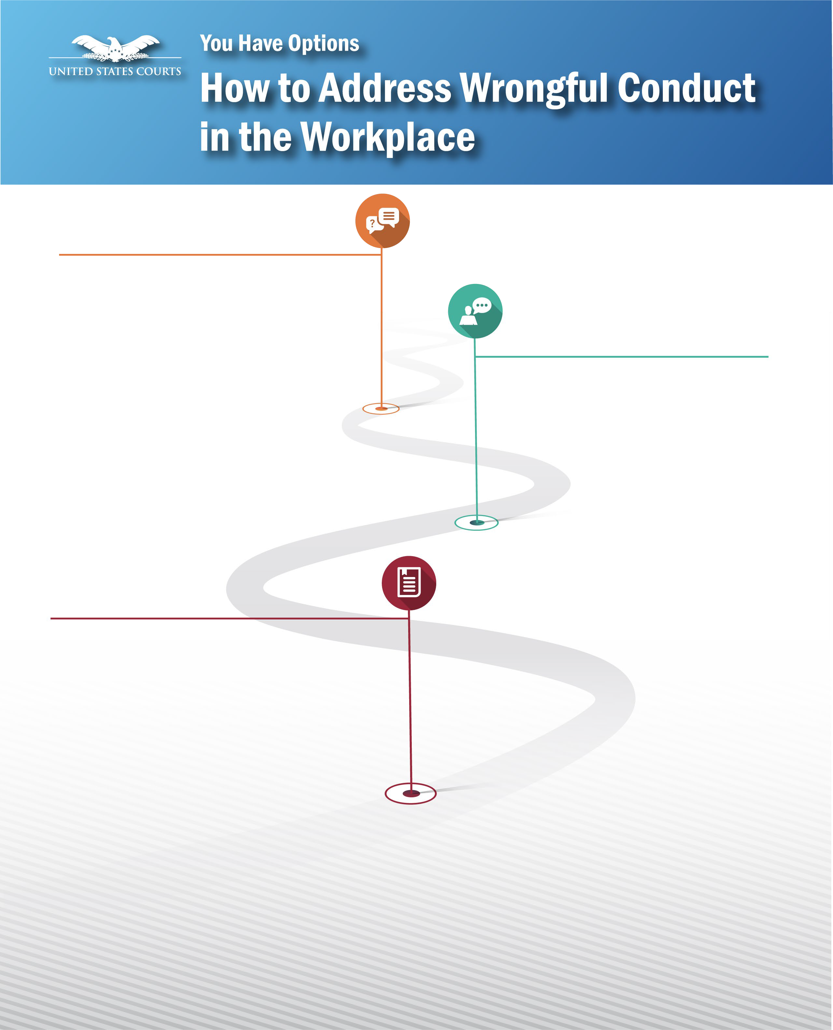






FORMAL COMPLAINT
Contact an EDR coordinator to file a formal complaint.
The Complaint must be filed within 180 days of the alleged violation or the discovery of the violation. This formal process includes:
- Appointment of Presiding Judicial Officer
- An investigation and/or hearing if appropriate
- Written decision
- Appeal rights

Confidentiality
All options for resolution are intended to respect privacy of all involved to the greatest extent possible, and to protect the fairness and thoroughness of the process by which allegations of wrongful conduct are initiated, investigated, and ultimately resolved.

Effective date: September 17, 2021

Contact Information:
Local EDR Coordinator Alex Alvarez
Phone 304-324-4007
Email Alex_Alvarez@wvsd.uscourts.gov

Circuit Director of Workplace
Relations Leila Jabbar (Updated November 13, 2023)
Phone 804-916-2181
Email Leila_Jabbar@ca4.uscourts.gov

National Office of Judicial Integrity Michael Henry, Judicial Integrity Officer 202-502-1603
AO_OJI@ao.uscourts.gov

Employees of the Federal Judiciary are protected by the employment rights listed below, as described in Guide to Judiciary Policy, Vol. 12, Ch. 2.
Employees have options for resolution, including Informal Advice, Assisted Resolution, and filing a Formal Complaint. Formal Complaints must be filed within 180 days of when the Employee knew or should have known of the alleged violation. More information, including a list of court EDR Coordinators, can be found on JNet.
Employees may confidentially report workplace discrimination, harassment, abusive behavior, or retaliation to an EDR Coordinator, Circuit Director of Workplace Relations, or the Judicial Integrity Officer, Michael Henry, at 202-502-1604.

Protection from Unlawful Discrimination
Prohibits discrimination in personnel actions based on race, color, sex, gender, gender identity, pregnancy, sexual orientation, religion, national origin, age (40+), or disability.

Protection from Harassment Prohibits sexual harassment, discriminatory harassment, and
abusive conduct.

Protection for Exercising Workplace Rights
Prohibits intimidation, retaliation, or discrimination against employees who exercise their employment rights or report or oppose wrongful conduct, including whistleblower protection.

Family and Medical Leave Provides rights and protections for employees needing leave for
specified family and medical reasons.

Protection for Veterans and Members of the Uniformed Services
Protects employees performing service in the uniformed services from discrimination and provides certain benefits and reemployment rights.

Notification of Office Closings and Mass Layoffs
Under certain circumstances, requires that employees be notified of an office closing or of a mass layoff at least 60 days in advance of the event.

Hazard-Free Workspaces Requires employing offices to comply with occupational safety and health
standards, and provide workplaces
free of recognized hazards.

Polygraph Testing Prohibition Restricts the use and the results of polygraph testing.



These rights are fully explained in Guide to Judiciary Policy, Vol. 12, Ch. 2.

Effective date: September 17, 2021

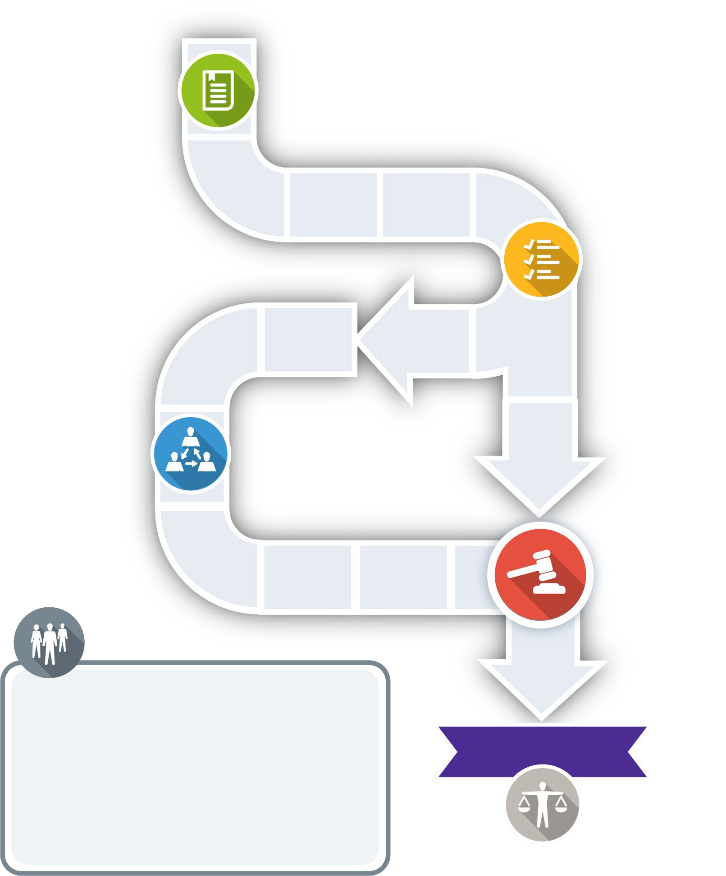


File a Complaint
File a complaint with an EDR coordinator within 180 days of the conduct (or discovery
of the conduct). Gather

Information
The Presiding Judicial Officer decides what investigation and discovery are needed and if written arguments are needed.

Hearing
The Presiding Judicial Officer determines if a hearing is needed.

RIGHTS

DECISION

- An impartial investigation and/or hearing, if appropriate.
- Both parties may use a representative or attorney (at own expense).
- Both parties may present witnesses and examine adverse witnesses.
- A prompt written decision by a Presiding Judicial Officer.
- Appeal.
Effective date: September 17, 2021

APPEAL

Parties have the right to appeal to the circuit judicial council within 30 days of a decision.

